Français 1B Nom_________________
Education Date________________
Étudiant A

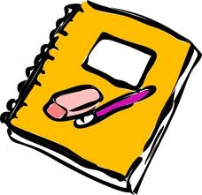
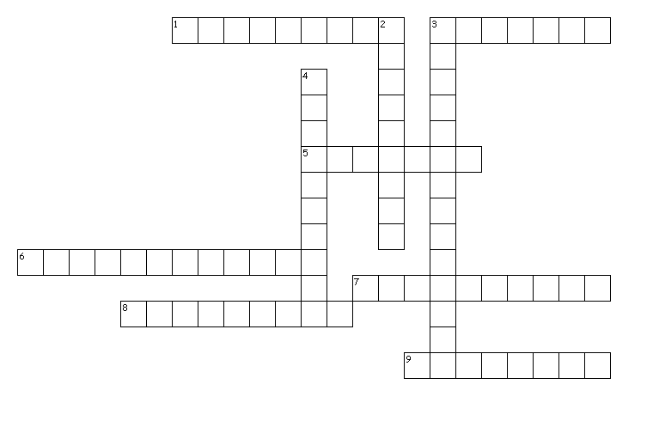

Across
1. You need these to cut things.
7. You listen to announcements on this.
8. Your teacher sits here.
9. Your notebook is filled with this.
Down
2. Use this to find the meaning of a word.
3. You salute this in advisory.
4. Look here for the time.
5. You use this to measure things.
6. Your teacher writes on the board with this.
7. You take notes in this.

Français 1B Nom__________________
Education Date__________________

Étudiant B

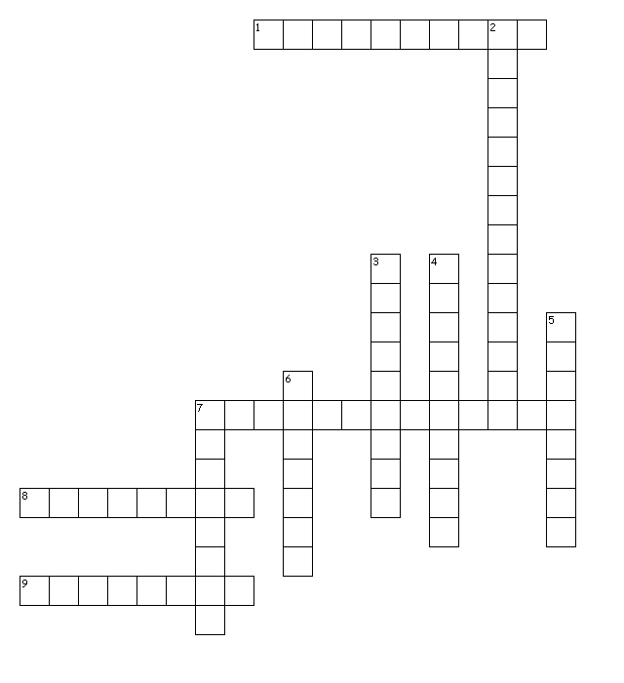

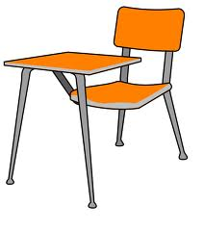

Across
1. Your teacher writes on this.
3. You write with this.
5. You stick pictures onto your projects with this.
6. You throw your trash in here.
7. You carry your things to school in this.
8. You sit here.
9. You erase the mistakes on your paper with this.
Down
2. Your teacher erases the board with this.
3. You sharpen your pencil with this.
4. You keep your papers in this.

