

**Corazones y Diamantes**

**Juego de Cartas**

**\*\*\*\*\*\*\*\*\*\*\*\*\*\*\***

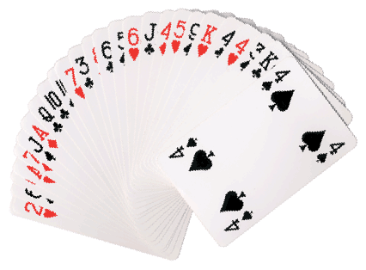



**Corazones y Diamantes**

|  |  |  |  |  |  |  |  |
| --- | --- | --- | --- | --- | --- | --- | --- |
|  | **AS** | **2** | **3** | **4** | **5** | **6** | **7** |
| Macintosh HD:Users:jjcabral:Desktop:Screen Shot 2013-05-11 at 4.35.42 AM.png |  |  |  |  |  |  |  |
| Macintosh HD:Users:jjcabral:Desktop:Screen Shot 2013-05-11 at 4.35.06 AM.png |  |  |  |  |  |  |  |
| Macintosh HD:Users:jjcabral:Desktop:Screen Shot 2013-05-11 at 4.35.35 AM.png |  |  |  |  |  | Image result for clothes clipart |  |
| Macintosh HD:Users:jjcabral:Desktop:Screen Shot 2013-05-11 at 4.35.28 AM.png |  |  |  |  |  |  |  |

|  |  |  |  |  |  |  |
| --- | --- | --- | --- | --- | --- | --- |
|  | **8** | **9** | **10** | **sota** | **Reina** | **Rey** |
| Macintosh HD:Users:jjcabral:Desktop:Screen Shot 2013-05-11 at 4.35.42 AM.png |  |  |  |  |  |  |
| Macintosh HD:Users:jjcabral:Desktop:Screen Shot 2013-05-11 at 4.35.06 AM.png |  |  |  |  |  |  |
| Macintosh HD:Users:jjcabral:Desktop:Screen Shot 2013-05-11 at 4.35.35 AM.png |  |  |  |  |  |  |
| Macintosh HD:Users:jjcabral:Desktop:Screen Shot 2013-05-11 at 4.35.28 AM.png |  |  | Image result for clothes clipart |  |  |  |

**Set-Up and Play:**

* This activity requires very little prep. All that is needed is a deck of regular player cards (minus the Jokers) and one or two copies of the previous page for players to reference during the game.
* Students can play in groups of two or three.
* Choose a dealer to deal out all of the cards in the deck evenly to all players (2 players-26 cards each; 3 players-17 cards each)
* Players place their pile of cards face down in front of them.
* All together, payers flip over their top card. The player with the highest value (ace is low, king is high) locates the picture that corresponds to that card (3 of hearts, king of diamonds, 4 of clubs, 7 of spades, etc.) on the reference sheet and says the word in Spanish. He then takes the cards and adds them to his point pile.
* If the player with the highest card is not able to identify the image, the player with the second highest card can win the hand by identifying the image the player with the highest card was not able to identify.
* If there is a tie for highest card, the winner is the one who identifies his/her image first.
* Once the deck is used up, all players count the cards that they placed aside and record their scores on a sheet of paper. All the cards are reshuffled and play continues.
* The teacher can decide the end point. (Go through the deck two or three times, first player to 30, 40, 50, 60 points).

**Vocabulary:**

* ########
* ########
* ########
* Corazón
* Diamante
* Trébol
* Pica
* Rey
* Reina
* Sota
* As